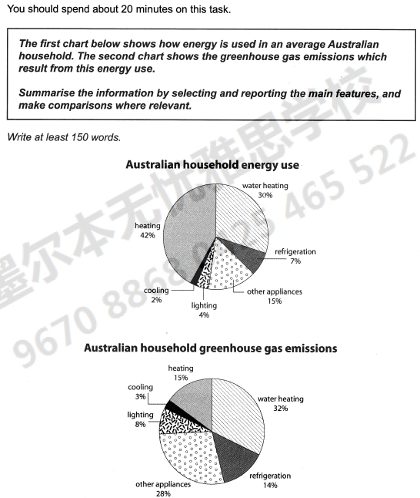

The pie charts present household energy use and household greenhouse gas emissions in Australian.

The first chart shows that heating is the most important part of household energy use in Australian, accounting for 42% of total energy use. Water heating is another main energy consumption household and accounts for 30% of total amount. Refrigeration, lighting and cooling are the other three ways of household energy using and their perception of energy consumption are 7%, 4% and 2%, respectively. Besides, other appliance occupied only 15% of household energy using.

The second chart shows that water heating holds 32% of household greenhouse gas emissions, and other appliance produces 28% of gas, only 4% less than water heating. Both heating and refrigeration are the other important greenhouse gas sources and produce around a half of that than other appliances.

In summary, heating and water heating are the main ways of household energy using in Australian, while water heating and other appliances are the main sources of greenhouse gas emissions.

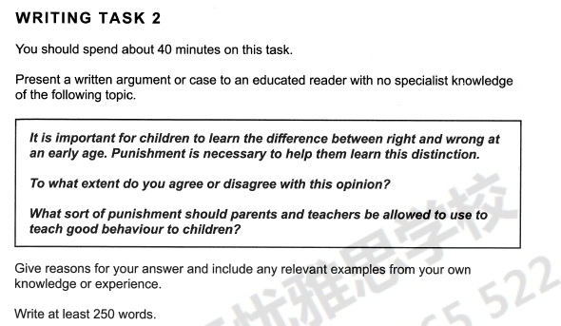

Learning the difference between right and wrong is very important for children, no matter in school or at home. It is helpful in children’s growing up. Punishment is recognized as a necessary method to help them learn this distinction because it is directive and effective.

Punishment is necessary, especially when children do wrong things. It prevents them from making similar mistakes in the future. When I was a child, I stole an eraser from one of my classmates, Chao. Fortunately, my father found that and punished me in a strict way. He shut me in a dark room for a whole day without water and food. From then on, I haven’t stolen anything anymore. He told me that if he had not punished me, I would have become a thief when I grow up. As a result, I would spend the rest of life in jail.

However, excessive punishment does not necessarily educate children. On the contrary, it spirals bad behaviours. It hurts children both in physical and mental. There were some news reported that some parents beaten them by sticks when kids make some small mistakes. Some children even suicide themselves, because they cannot bare that kind of punishment any more. Severe punishment sometimes cannot help children distinct right and wrong; on the contrary, it complexes the simple problems.

In my opinion, there are no two same children in the world. Different children have different characteristics. We’d better educate children in moderate ways. Appropriate punishment is useful, especially when there are no other choices.